

VISUALIZATION OF THE WEALTH OF NATIONS DATA USING EXCEL

Peace Lawson

9th February, 2023

### TABLE OF CONTENTS

TABLE OF CONTENTS 1

POLICIES AND PROCEDURES WHEN WORKING WITH DATA 2

1. PROTECTING THE WORKBOOK 2

2. HIGHLIGHT COLUMN C AND CHANGE THE DATA TO DISPLAY IN BRITISH POUND SYMBOL 2

3. TURNING THE GDP SHEET INTO A TABLE 3

4. FILTER THE TABLE TO DISPLAY ONLY THE INFORMATION FOR 2019 AND TOP 20 COUNTRIES 3

5. A CHART DISPLAYING THE FOLLOWING DATA ‘RANK, COUNTRYAND GDP-PER CAPITA (PPP) 4

6. USING YOUR CREATIVE SKILLS EDIT THE CHART 5

7. NEXT CREATE A NEW BAR CHART TO DISPLAY THE 20 HIGHEST RANKING COUNTRIES FROM YOUR SORT AND THEN MOVE THE CHART TO BE UNDERNEATH THE TABLE. 6

8. COLOUR THE BACKGROUND BY HIGHLIGHTING THE AREA UNDERNEATH THE TABLE. FIND THE ADD A FILL COLOUR ICON AND SELLECT A COLOUR. 6

9. THE NEXT TASK IS TO CREATE 3 MACRO BUTTONS, PRINT THE SHEET, SAVE THE FILE AND COPY THE SHEET. 7

**A REFLECTION** 9

TASK 1

## POLICIES AND PROCEDURES WHEN WORKING WITH DATA

Data protection is **the process of safeguarding important information from corruption, compromise or loss**. The Data Protection Act 2018 controls how your personal information is used by organisations, businesses or the government. It is the UK’s implementation of the General Data Protection Regulation (GDPR).

Everyone responsible for using personal data has to follow strict rules called data protection principles. They must make sure the information is:

* used fairly, lawfully and transparently
* used for specified, explicit purposes
* used in a way that is adequate, relevant and limited to only what is necessary
* accurate and, where necessary, kept up to date
* kept for no longer than is necessary
* handled in a way that ensures appropriate security, including protection against unlawful or unauthorised processing, access, loss, destruction or damage

TASK 2

**GDP TASK**

## PROTECTING THE WORKBOOK

This process was done by;

1. Go to Review
2. Click Protect Workbook
3. Dialog box pops up
4. Choose and modify password
5. Select ok

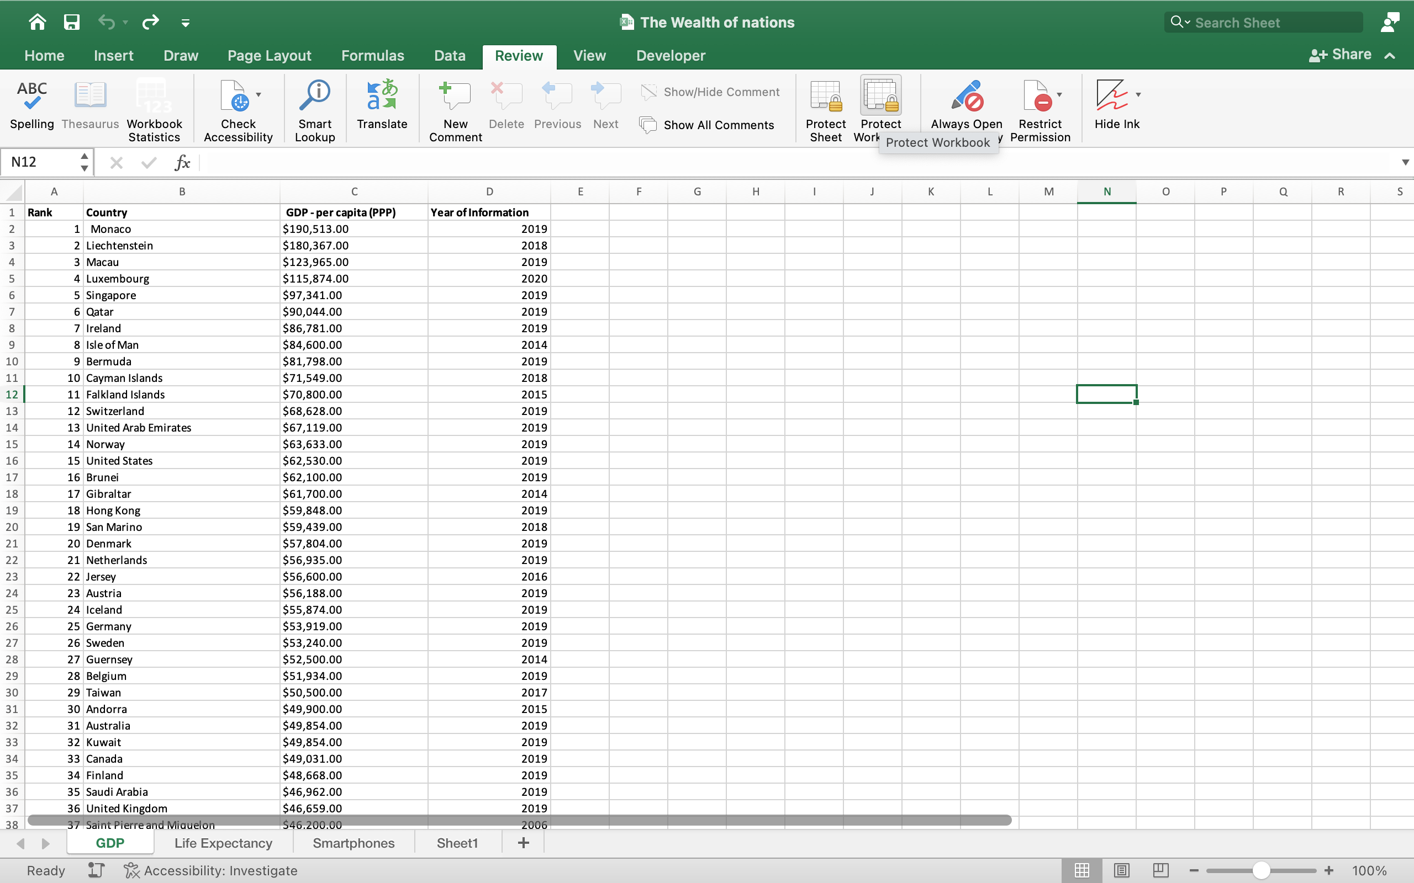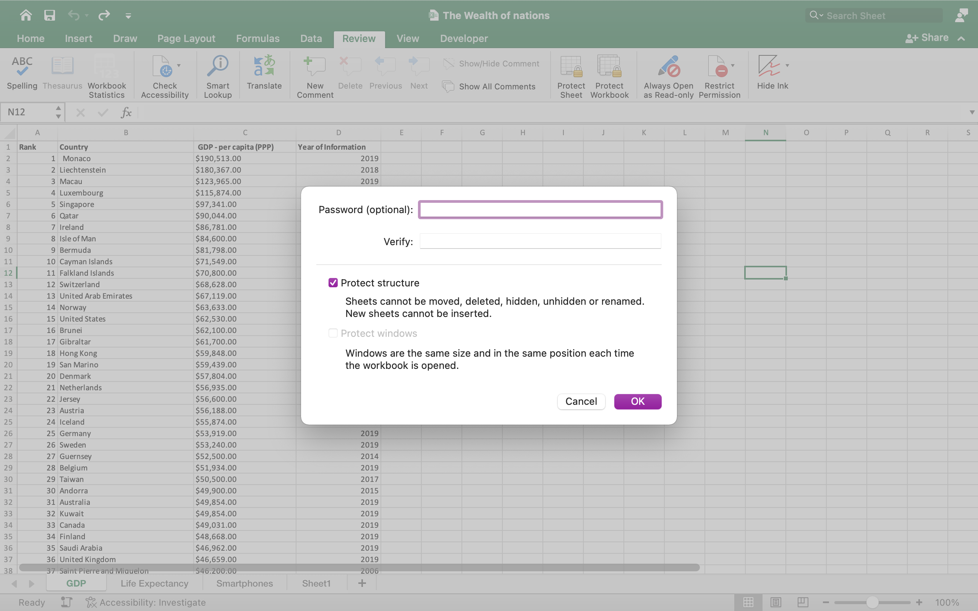

2

1

## HIGHLIGHT COLUMN C AND CHANGE THE DATA TO DISPLAY IN BRITISH POUND SYMBOL

This was done by;

1. Highlight column c.
2. Go to the currency symbol under accounting.
3. Choose £ English.

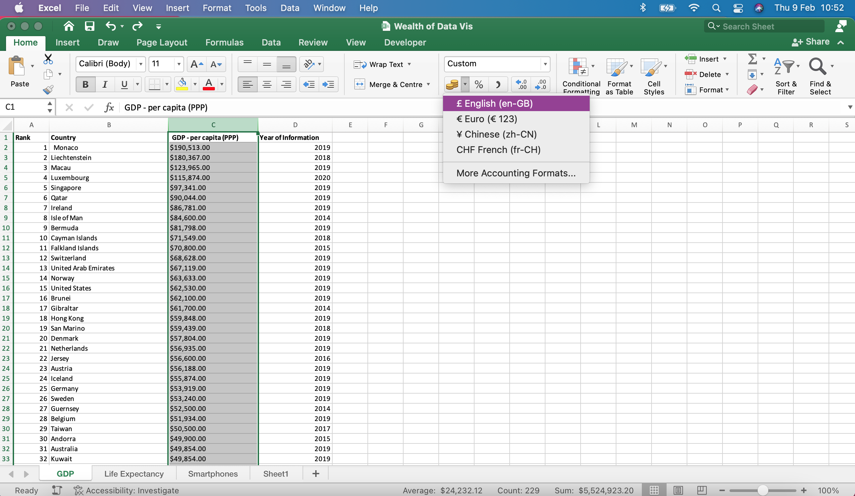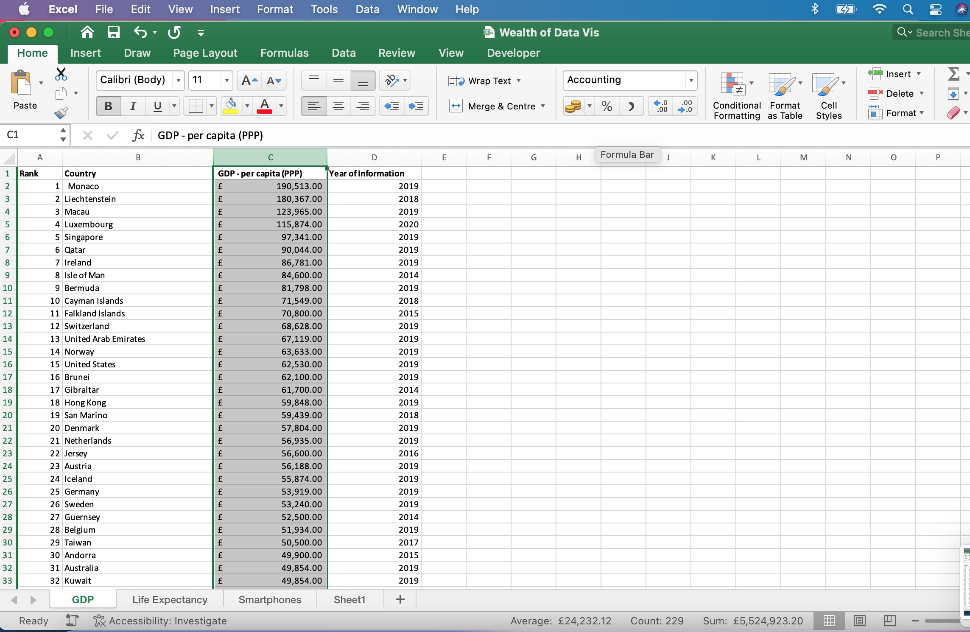

2

1

## TURNING THE GDP SHEET INTO A TABLE

1. Select the cells within data.
2. Select Home > Format as Table.
3. Choose a style for the table.
4. In the format as table dialog box, tick on my table has a header and press ok with the cell range selected.
5. Select ok.

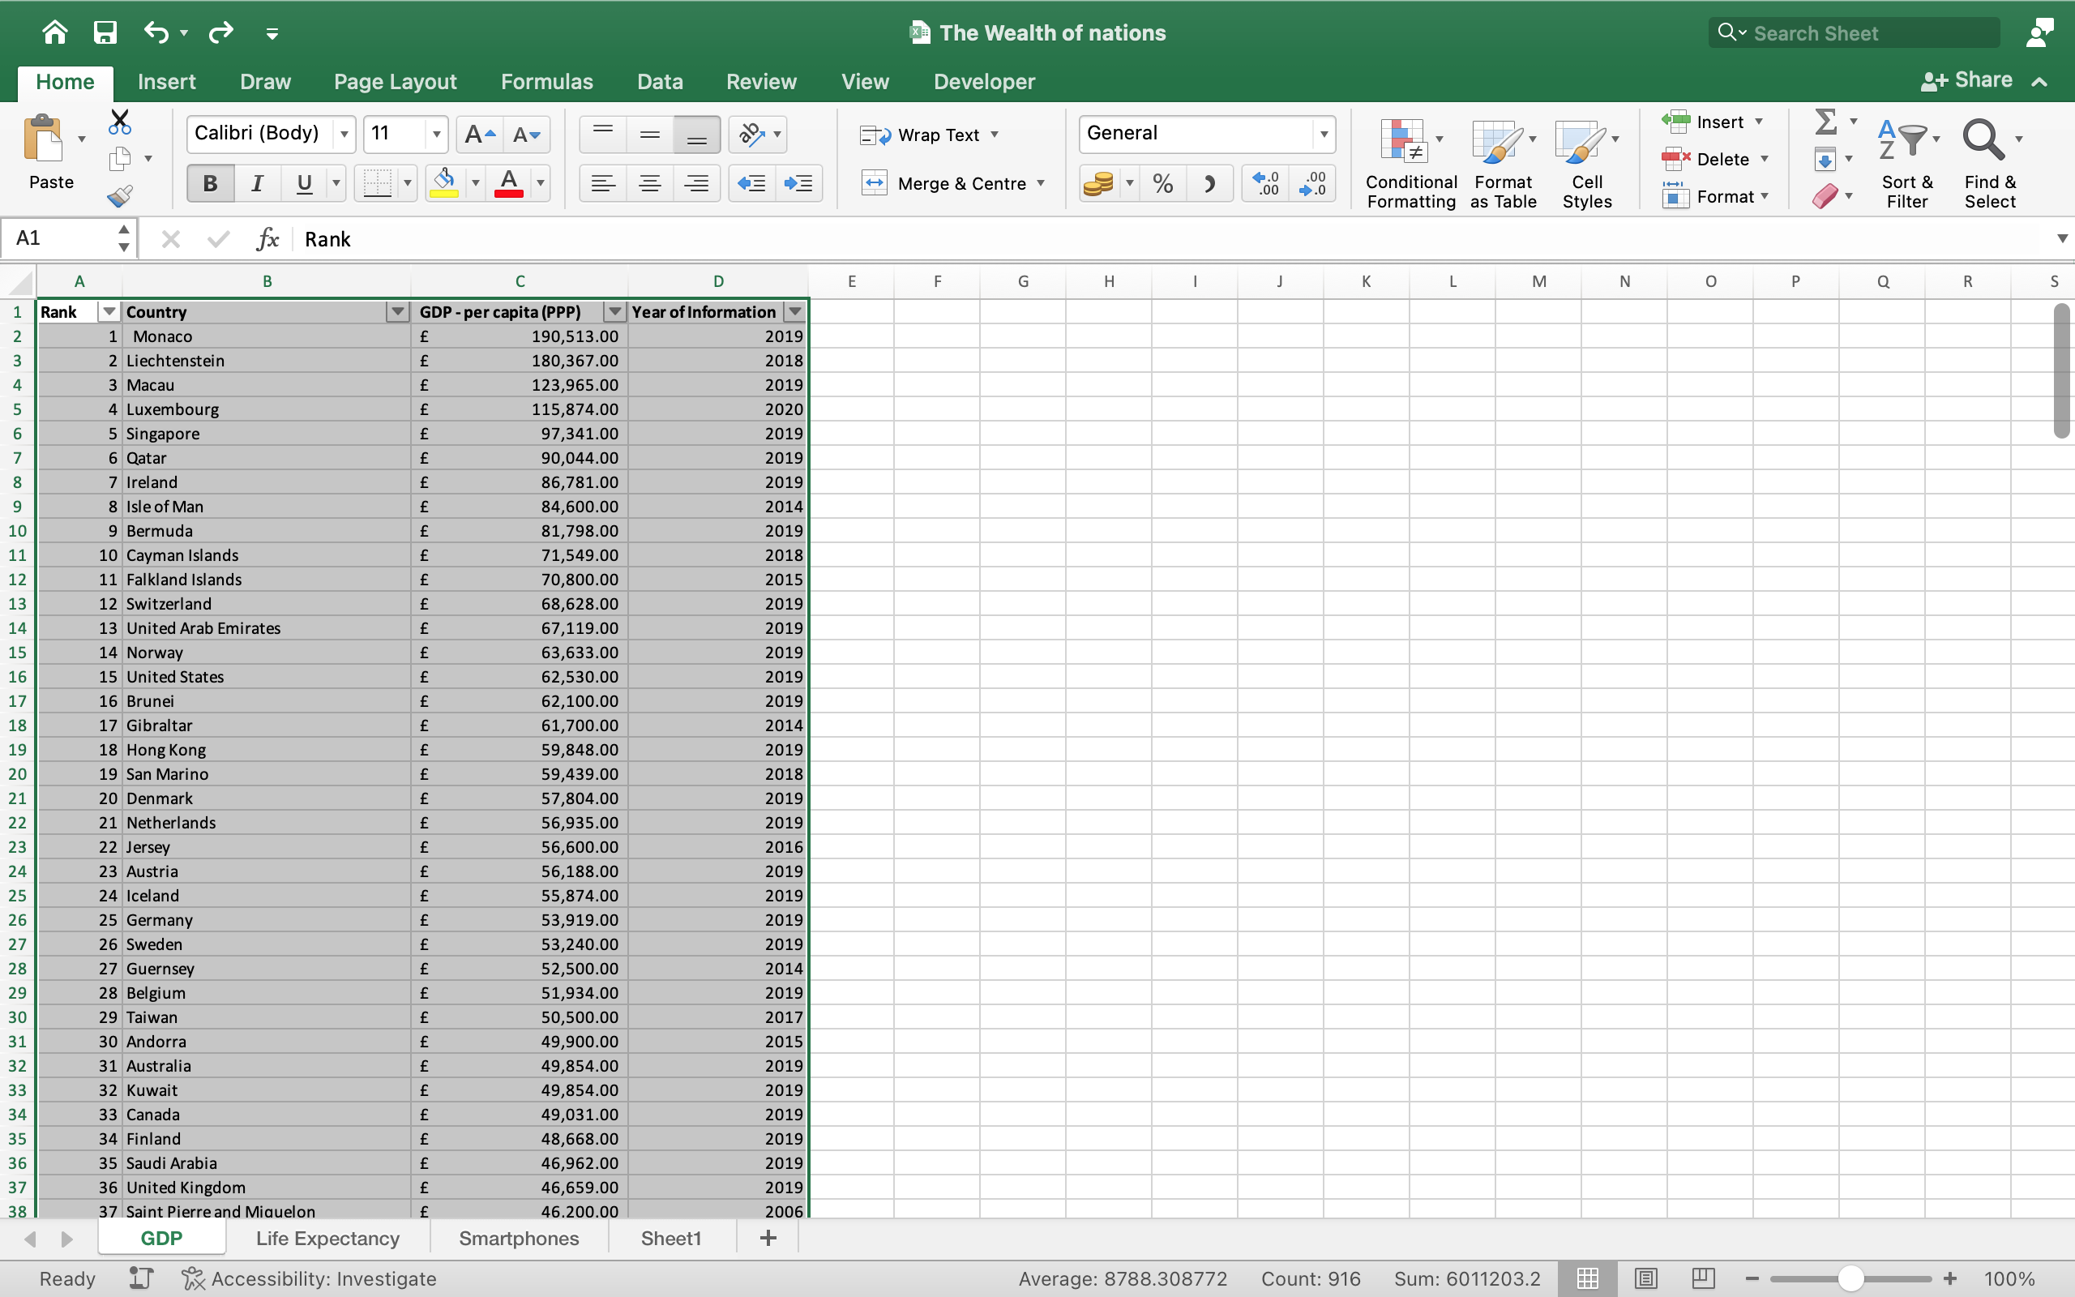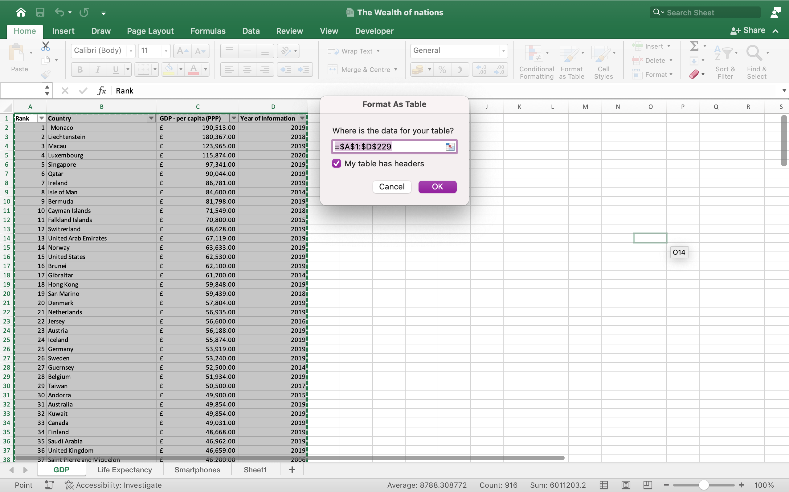

2

1

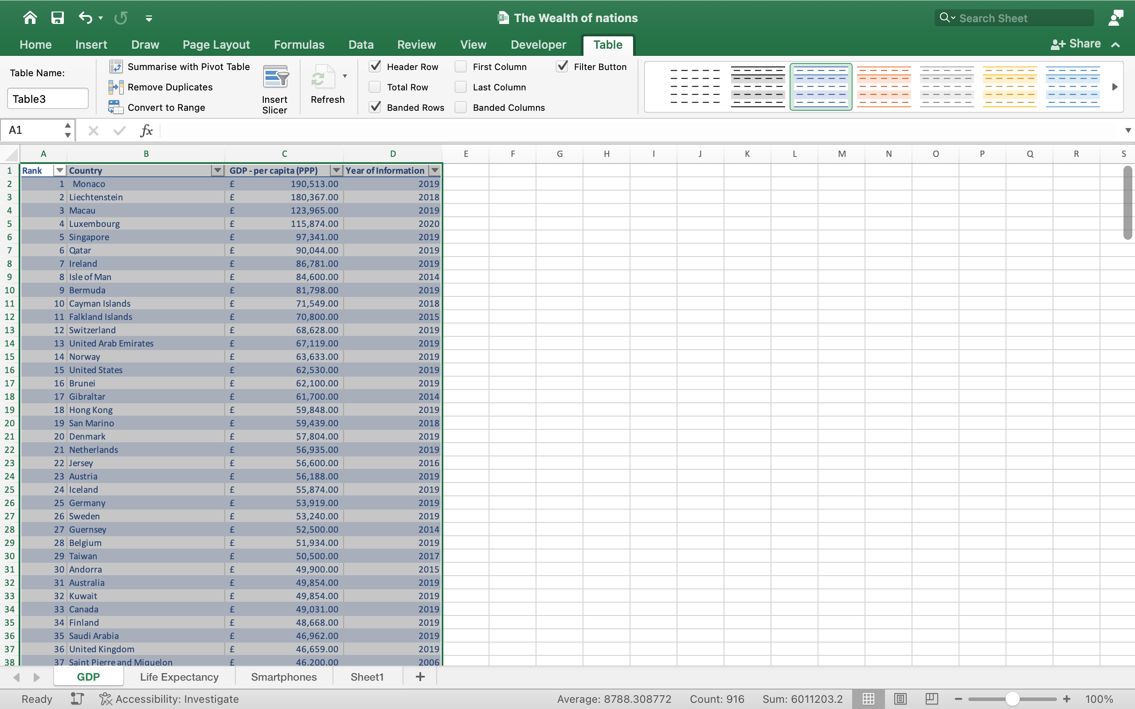

3

## FILTER THE TABLE TO DISPLAY ONLY THE INFORMATION FOR 2019 AND TOP 20 COUNTRIES

1. Select the dropdown from column D (year of information).
2. Untick select all.
3. Scroll down and tick 2019.
4. Click on an empty cell to see the changes apply.
5. Select dropdown from column B (country) the dialog box will pop up then select the option that says choose one.
6. Select Top 10.
7. Edit the 10 to 20.
8. Click on an empty cell to see the changes apply.

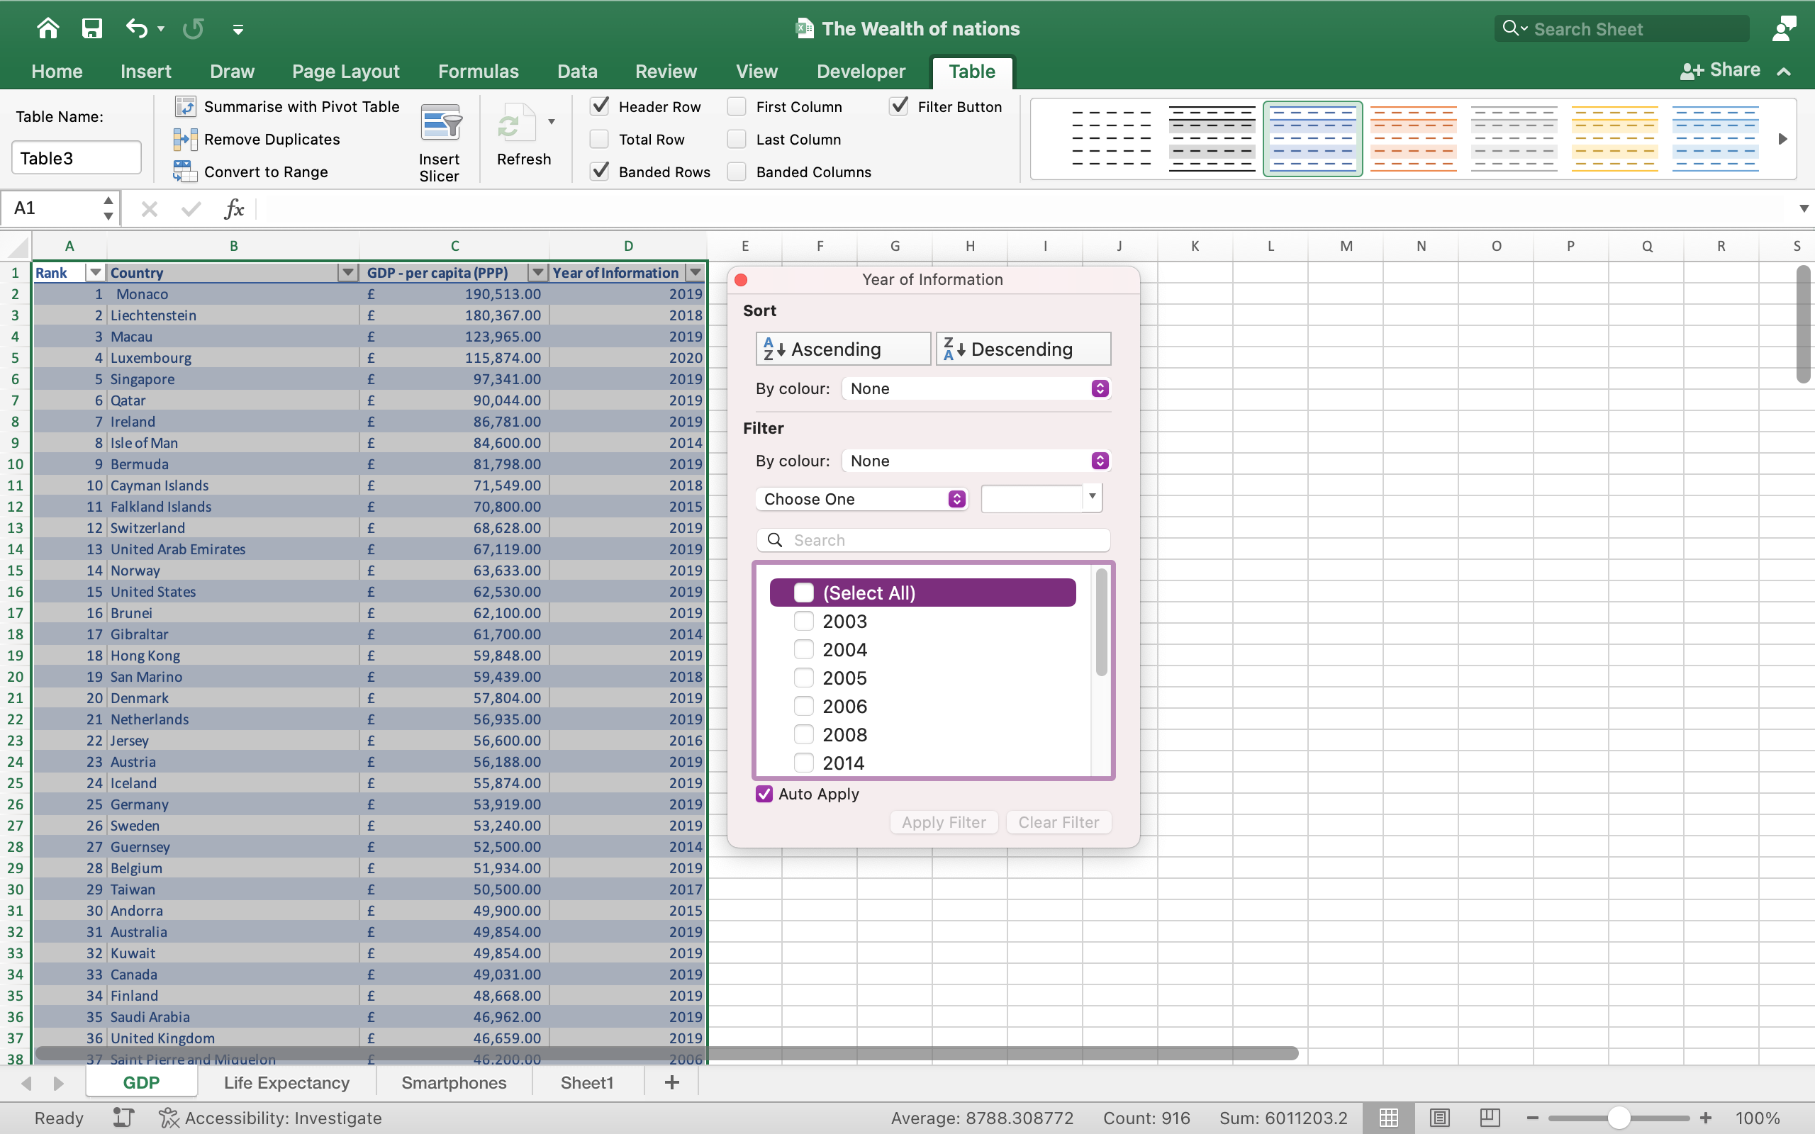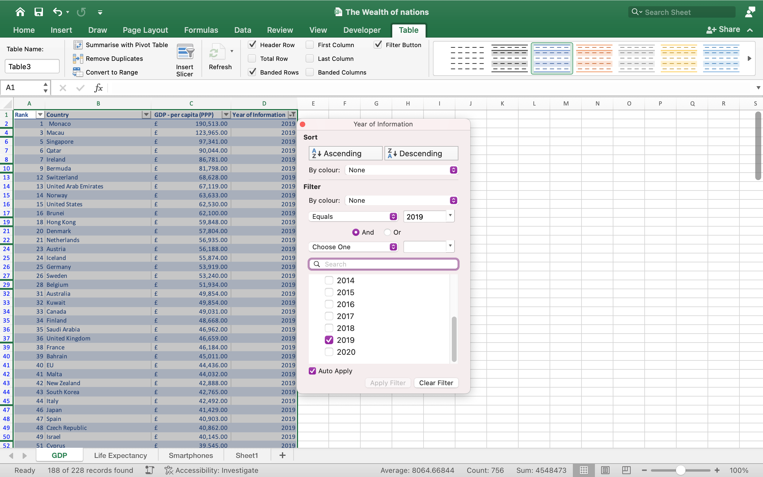

2

1

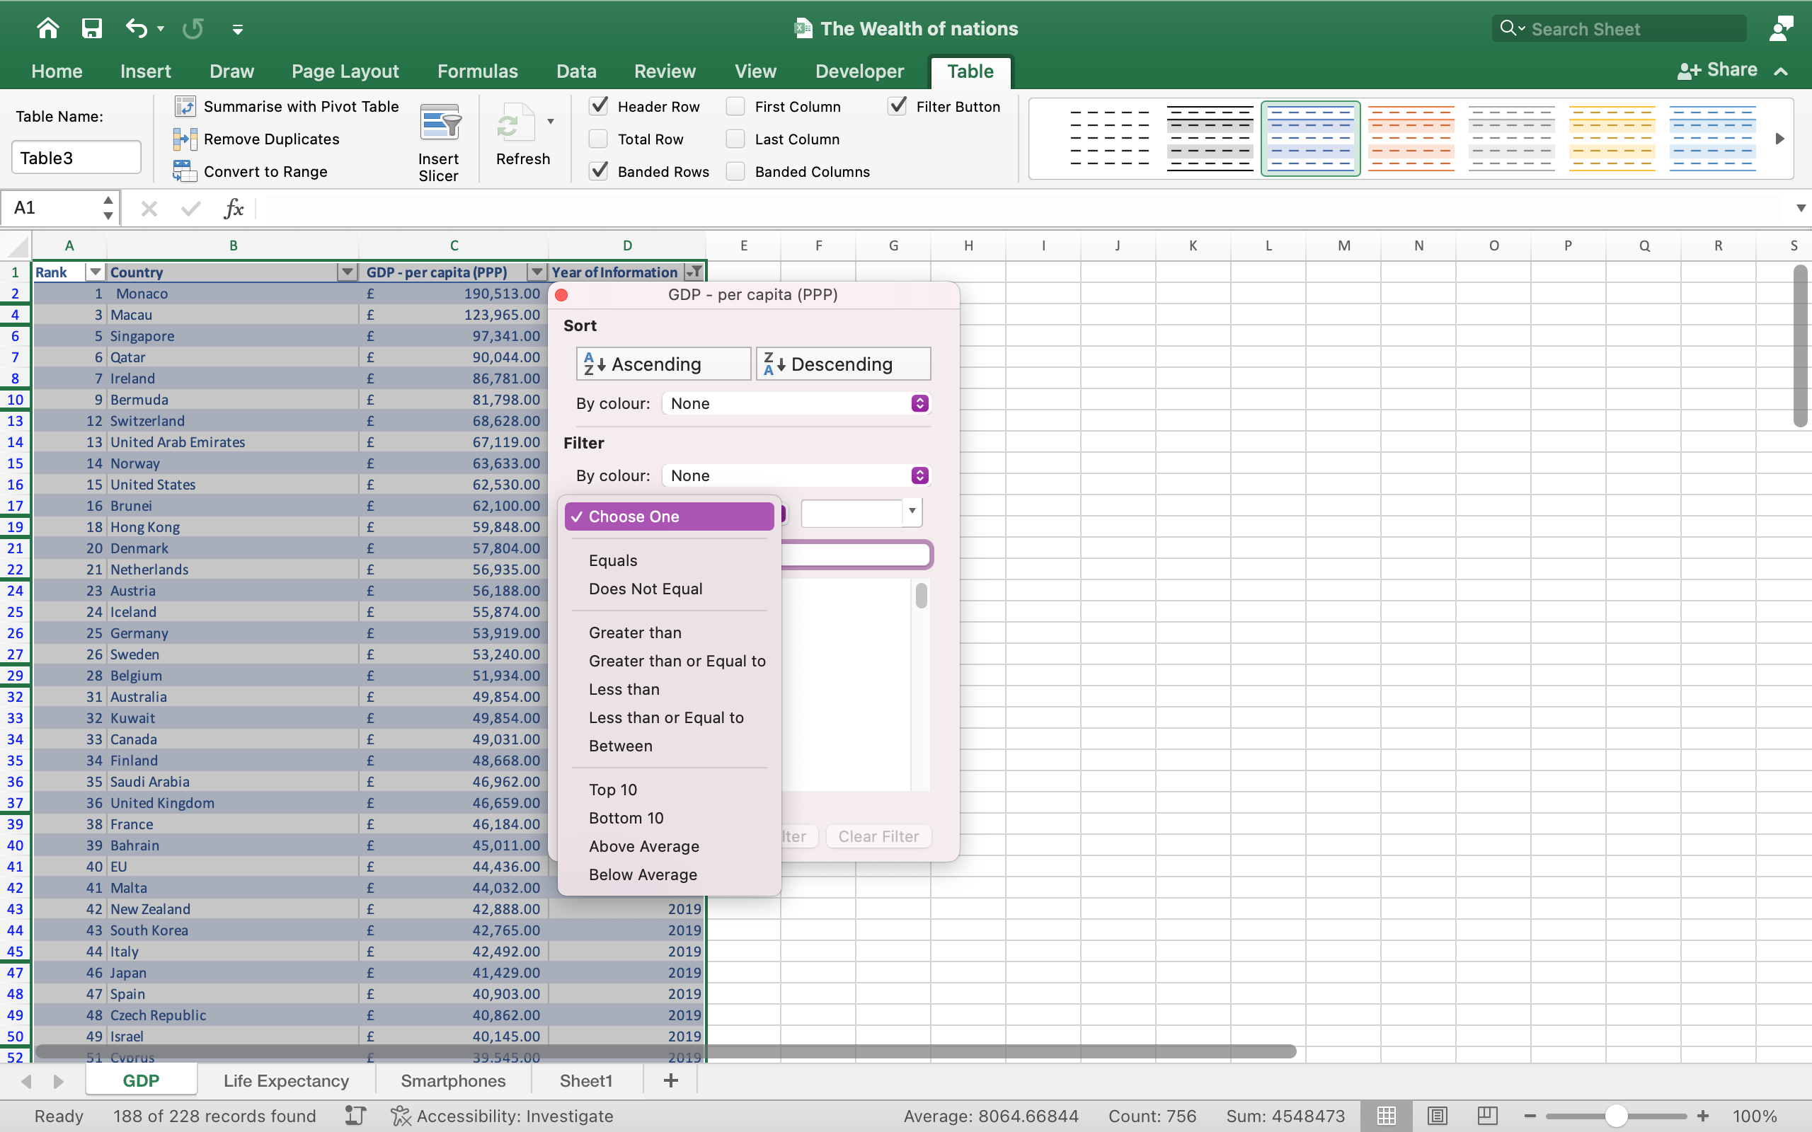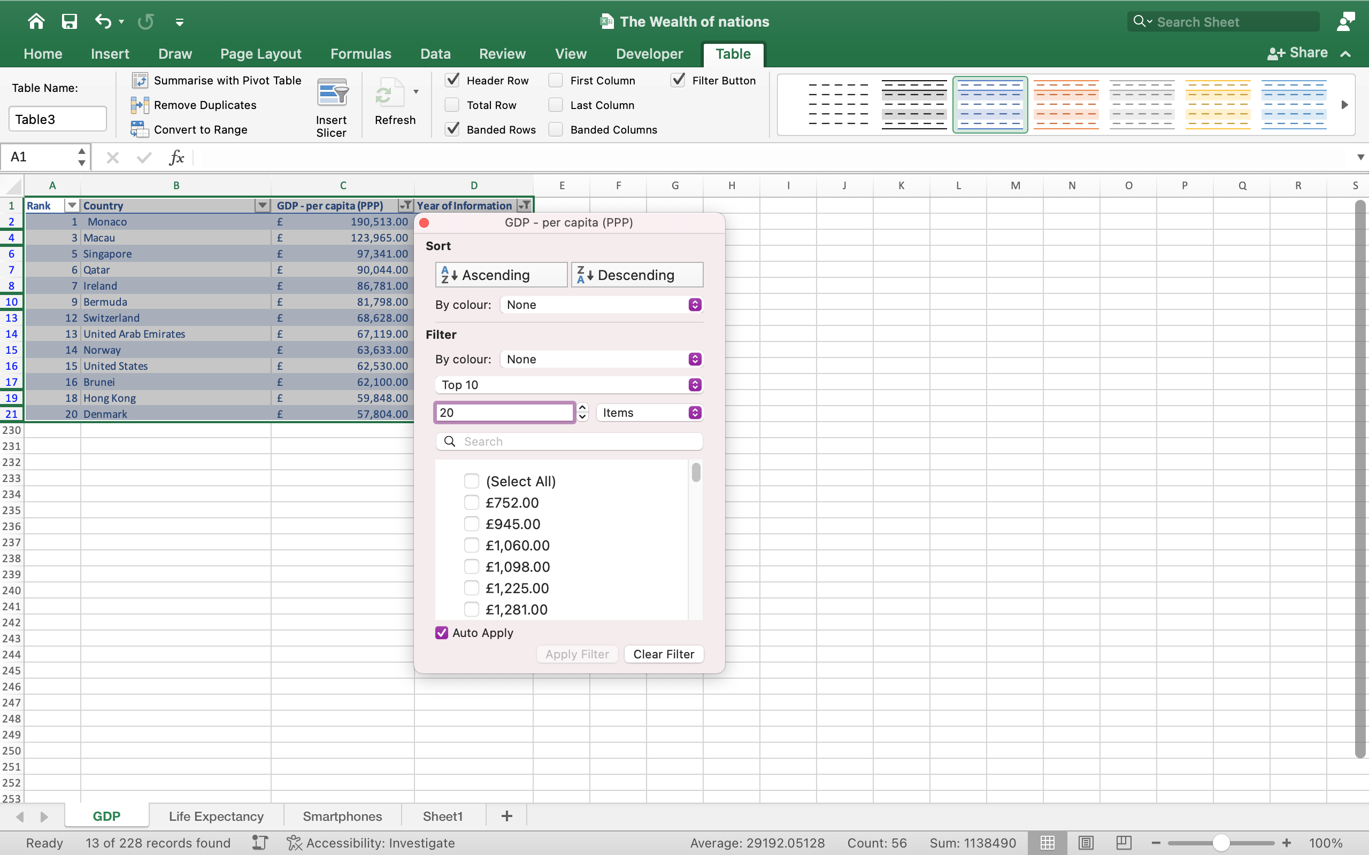

3

4

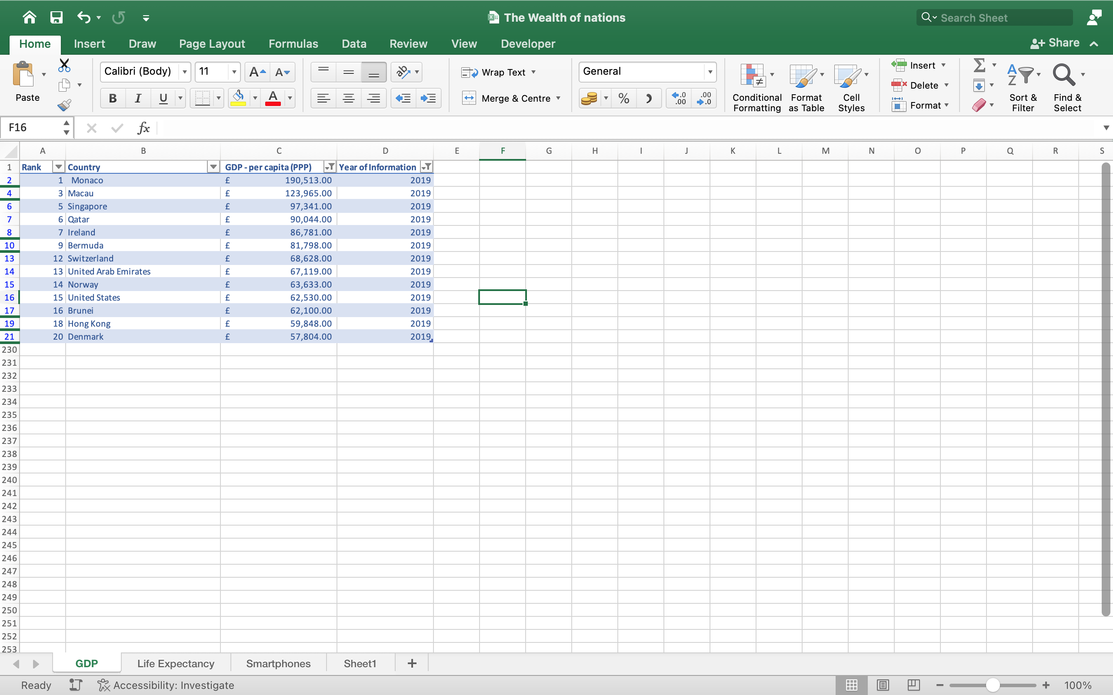

5

## A CHART DISPLAYING THE FOLLOWING DATA ‘RANK, COUNTRYAND GDP-PER CAPITA (PPP)

1. Select the data for which you want to create a chart.
2. Click INSERT > Recommended Charts.
3. On the Recommended Charts tab, scroll through the list of charts that Excel recommends for your data, and click any chart to see how your data will look.
4. When you find the chart you like, click it > OK.

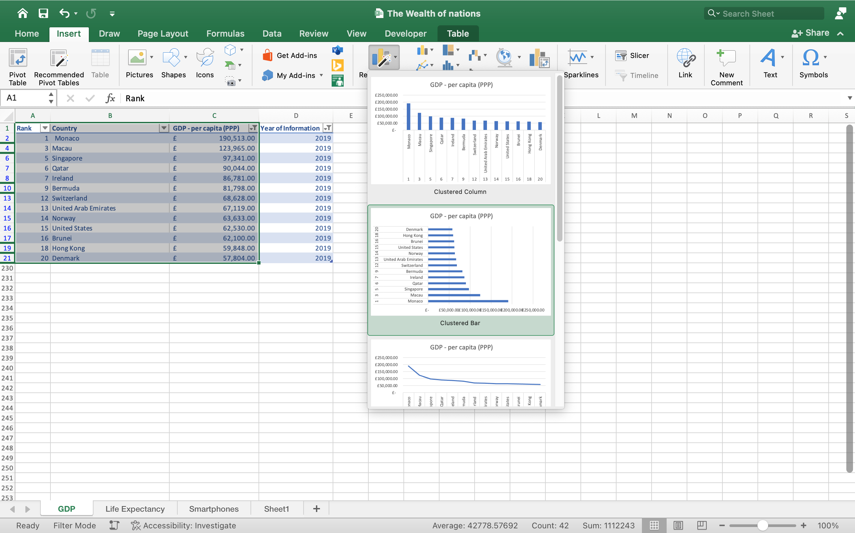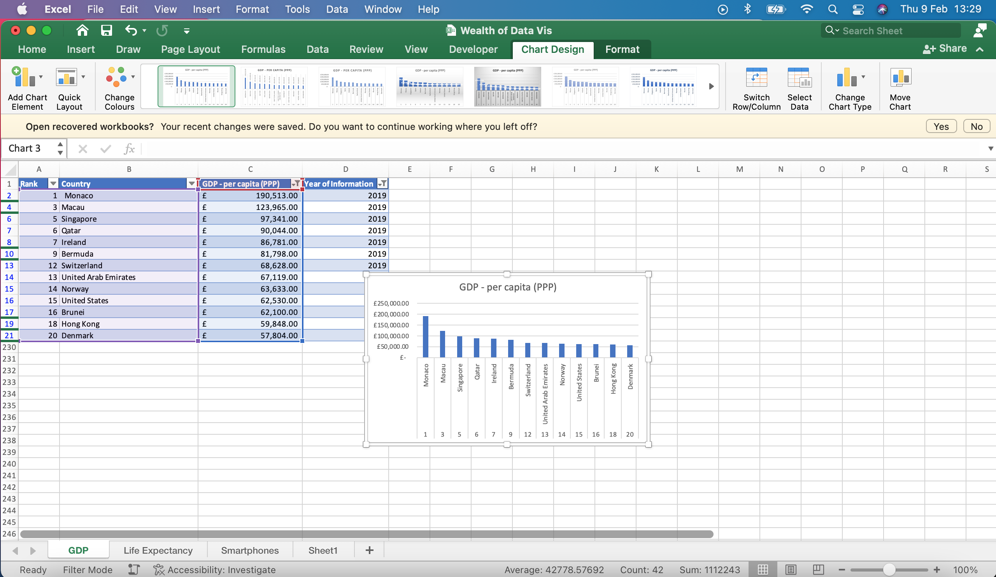

b

a

## USING YOUR CREATIVE SKILLS EDIT THE CHART

1. Add a title.

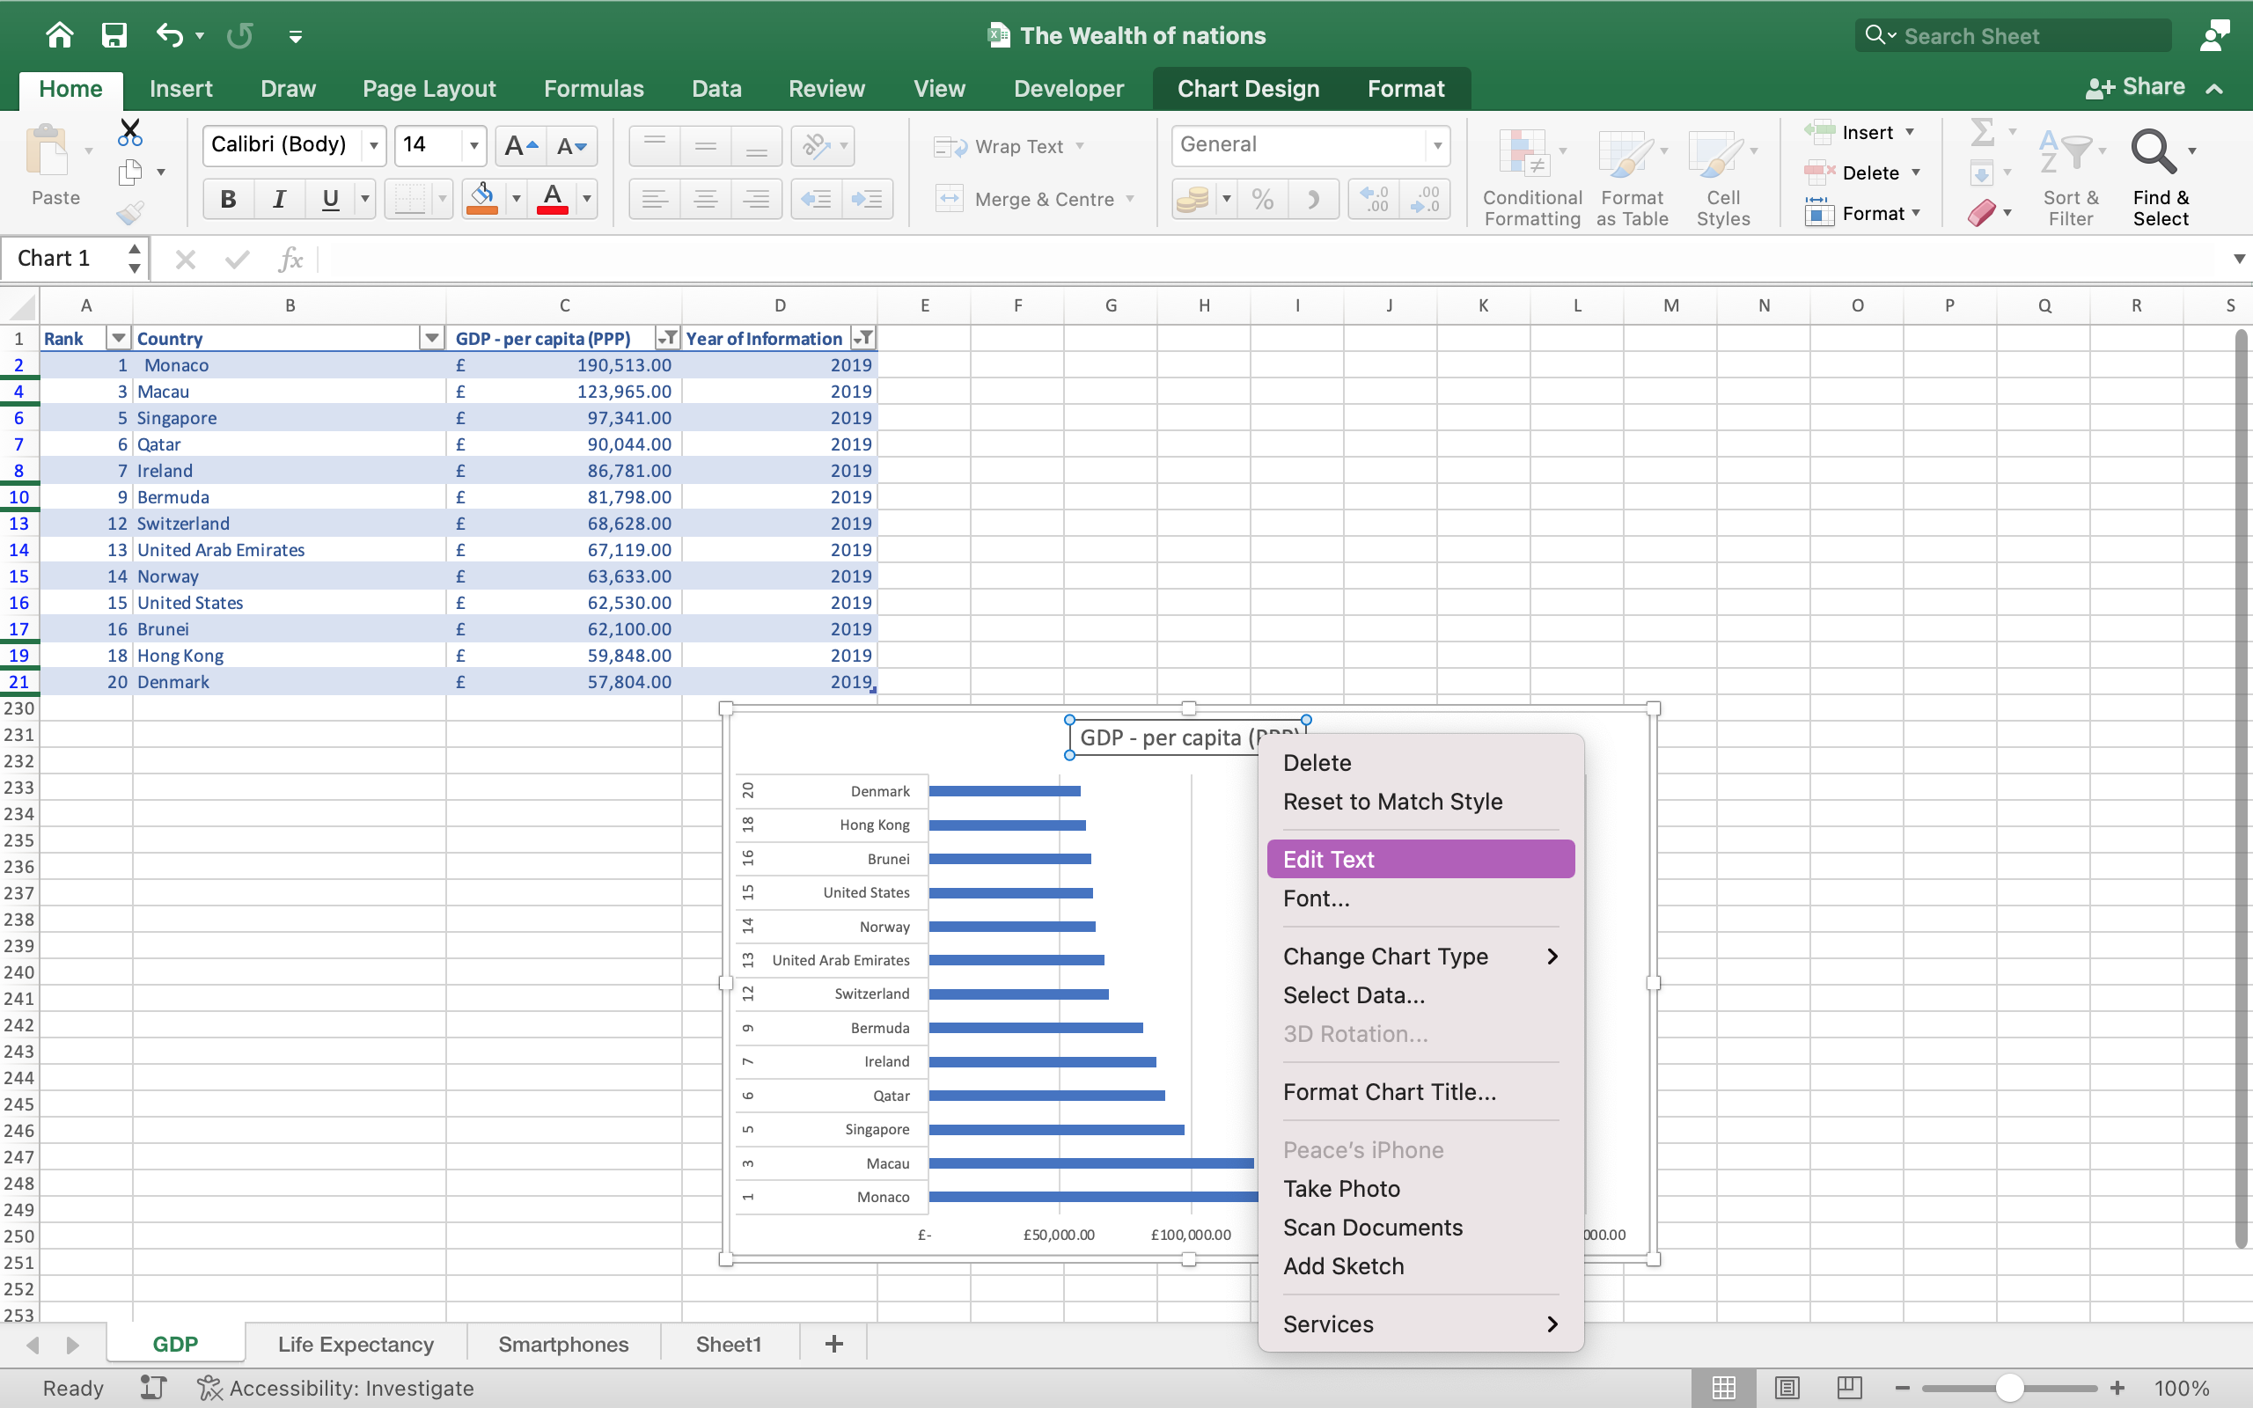

1. Add X and Y axis labels.

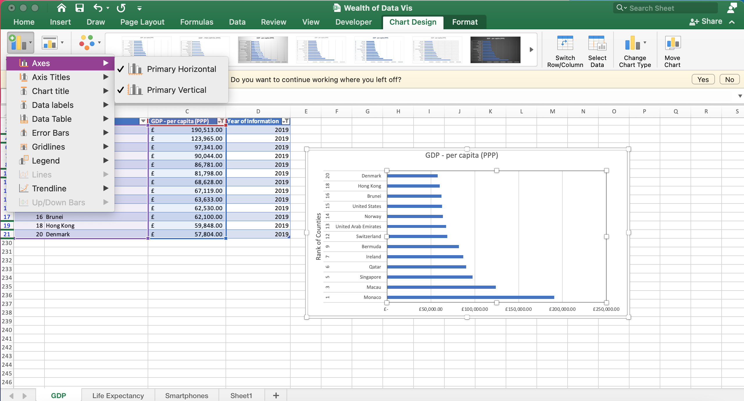

1. Make the chart visually pleasing.

## NEXT CREATE A NEW BAR CHART TO DISPLAY THE 20 HIGHEST RANKING COUNTRIES FROM YOUR SORT AND THEN MOVE THE CHART TO BE UNDERNEATH THE TABLE.

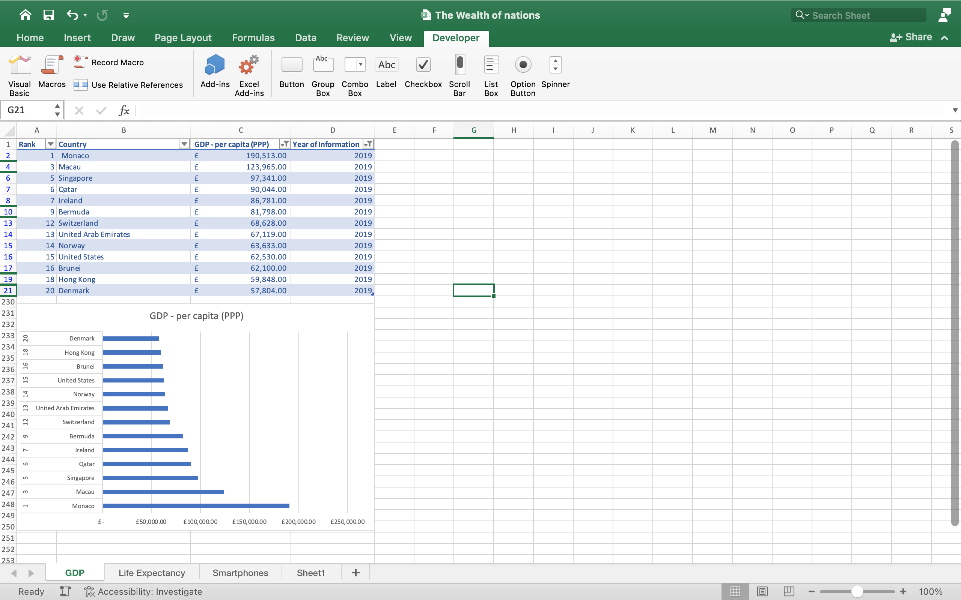

## COLOUR THE BACKGROUND BY HIGHLIGHTING THE AREA UNDERNEATH THE TABLE. FIND THE ADD A FILL COLOUR ICON AND SELLECT A COLOUR.

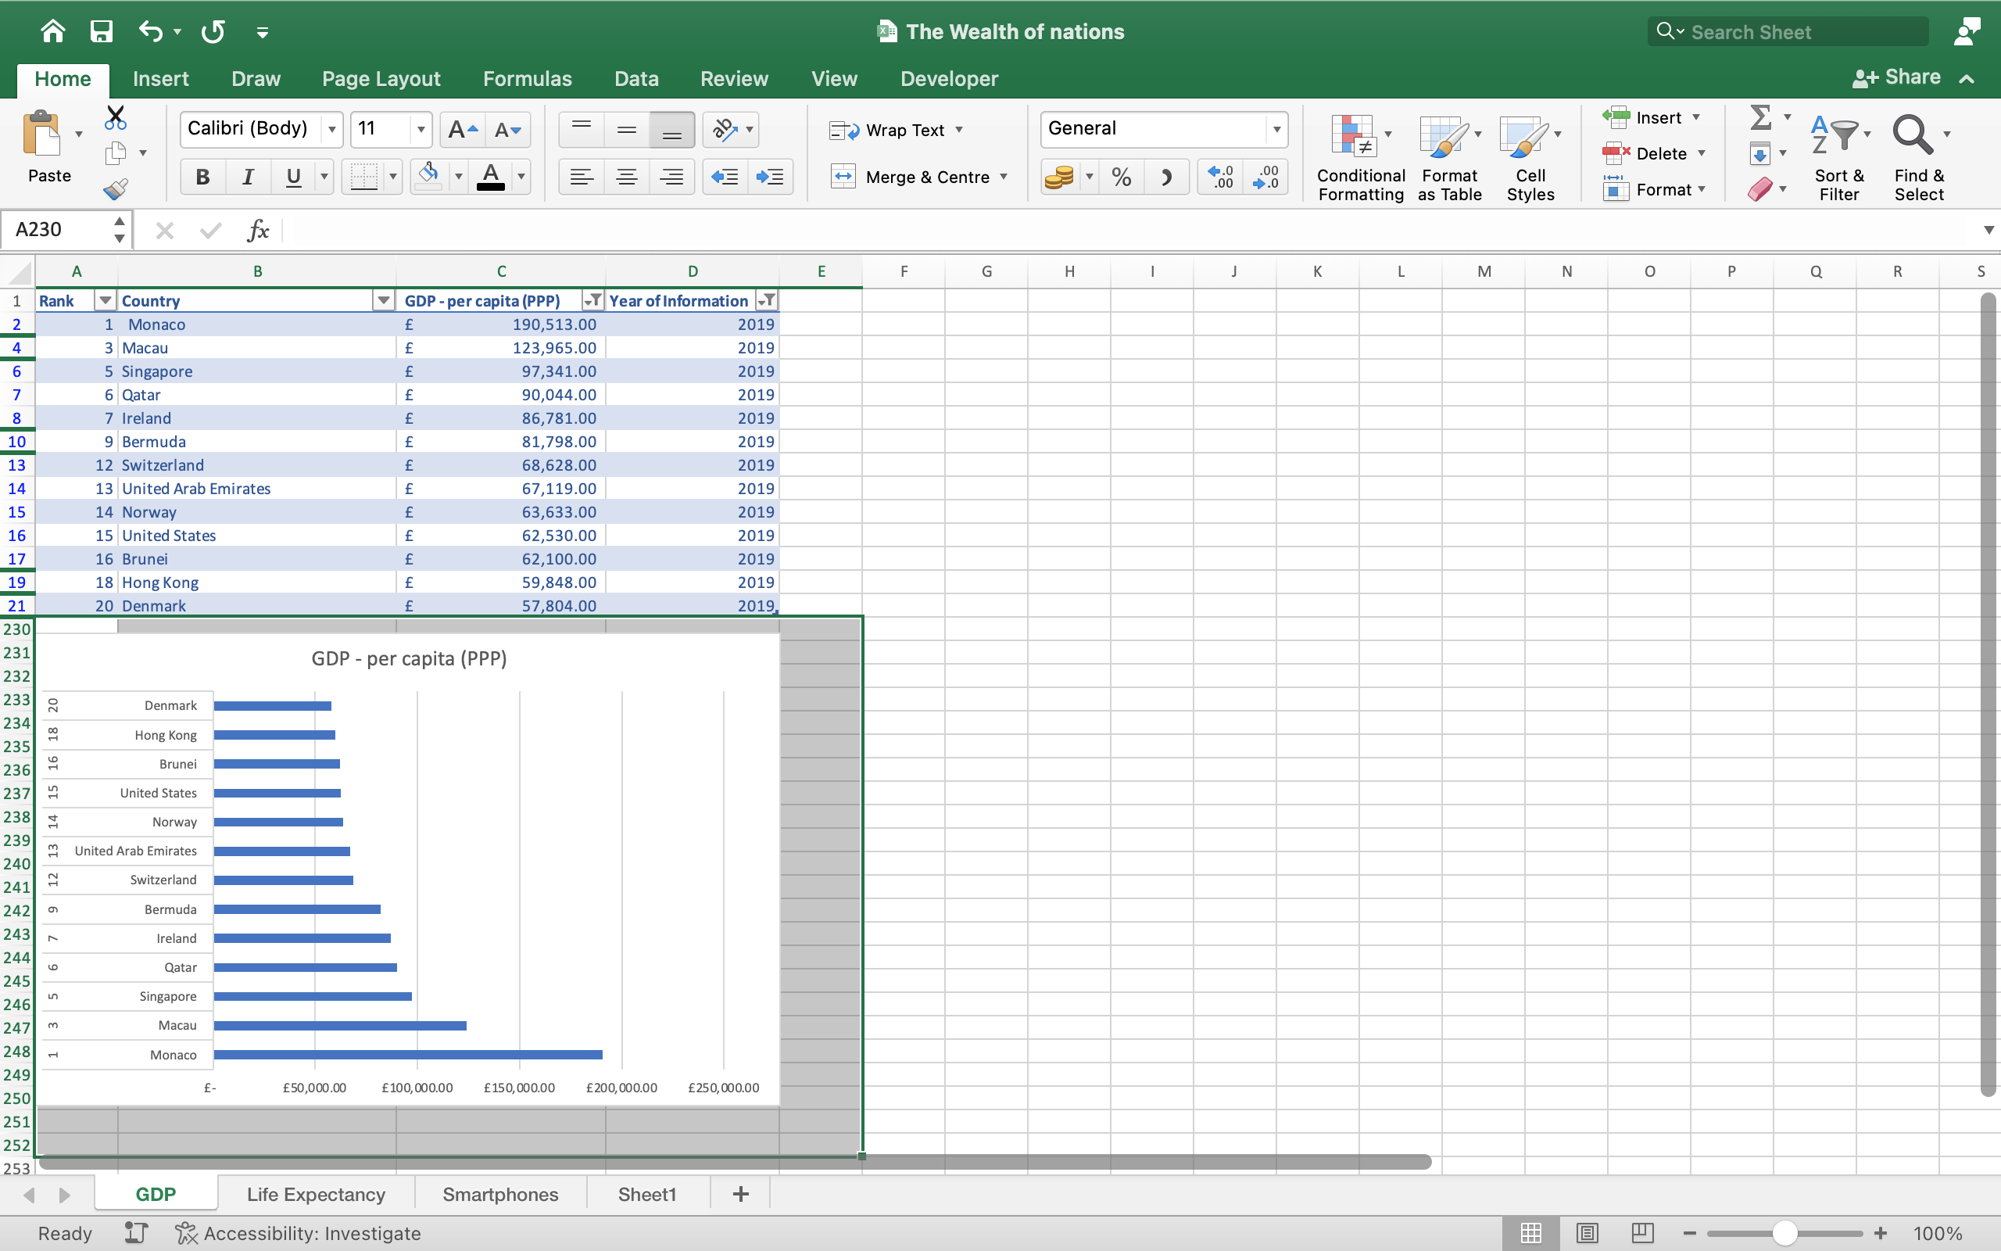

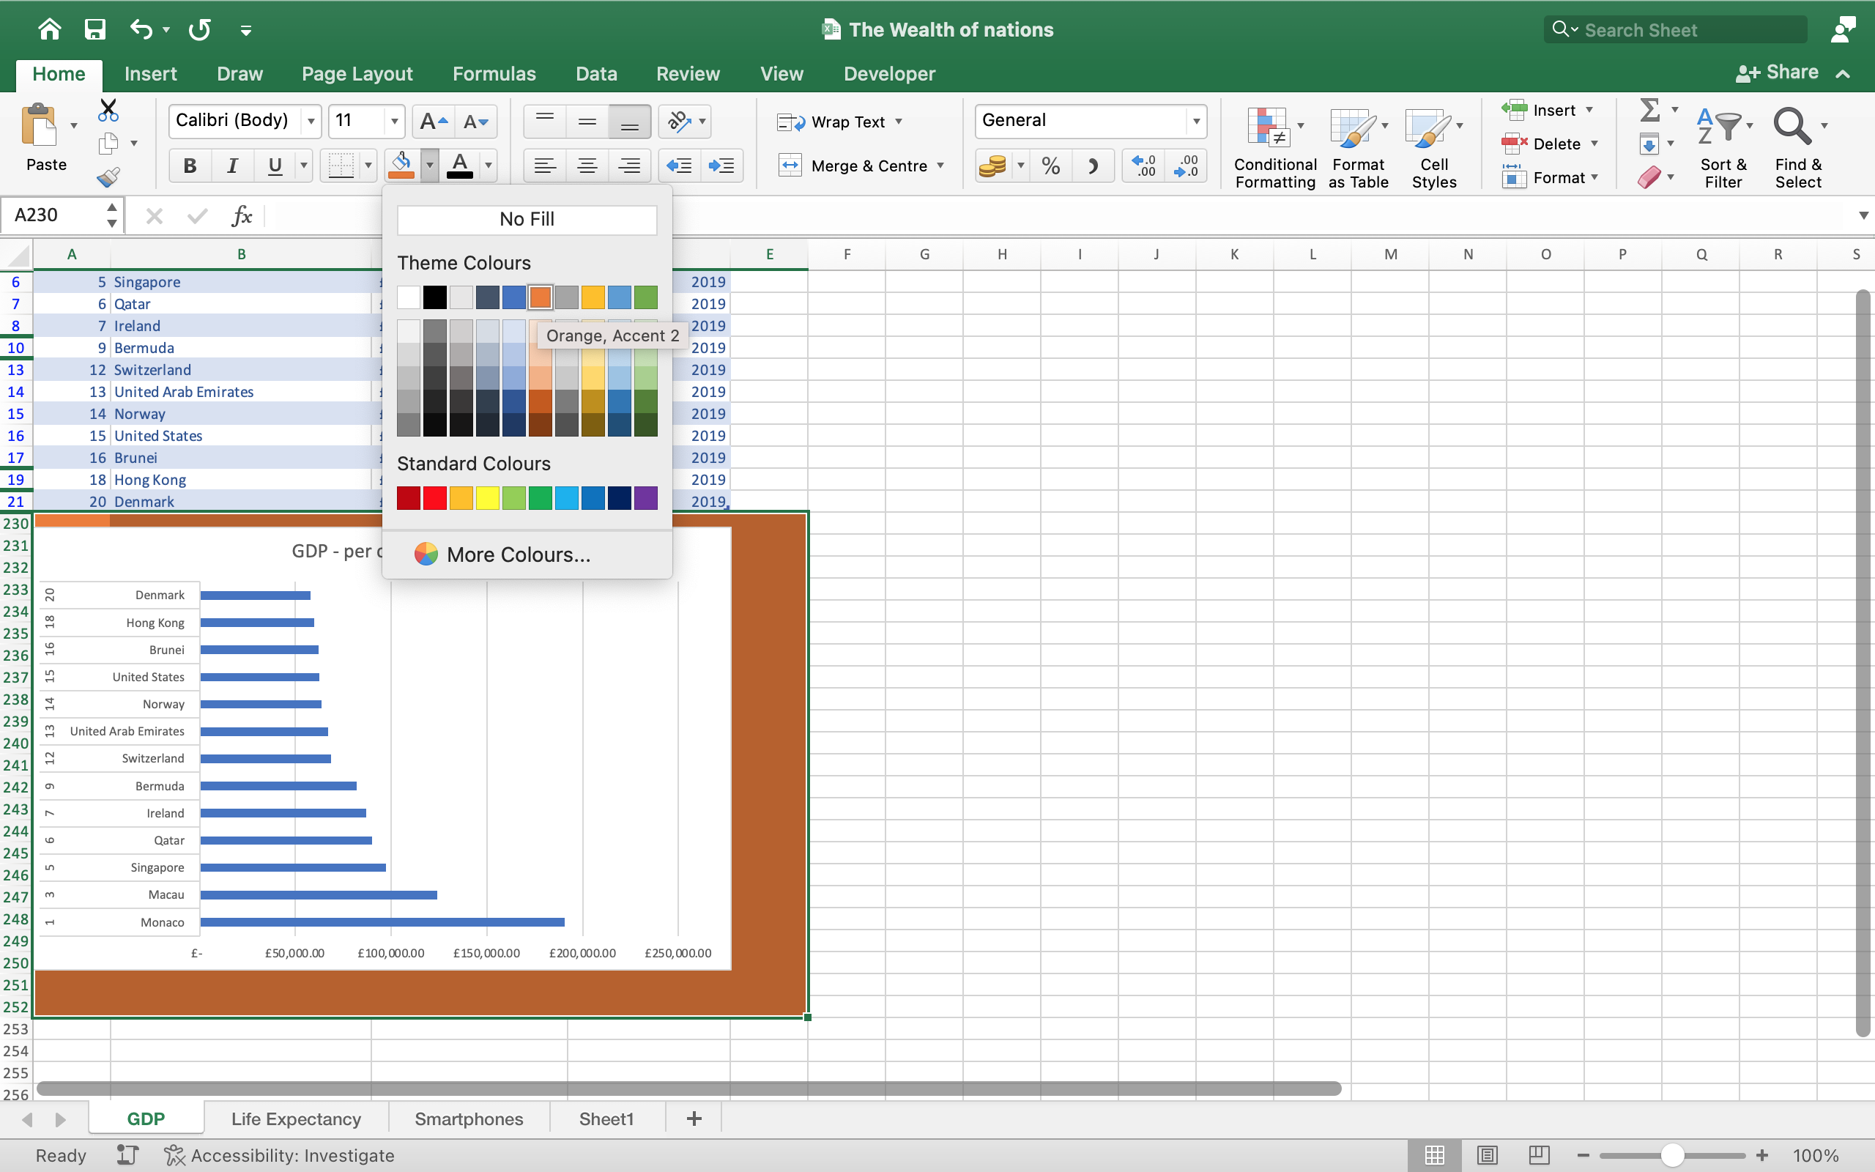

## THE NEXT TASK IS TO CREATE 3 MACRO BUTTONS, PRINT THE SHEET, SAVE THE FILE AND COPY THE SHEET.

1. Highlight the area to be copied.
2. Then go to developer
3. Select record macro
4. Then copy
5. Stop macro
6. Select button
7. Assign macro to button

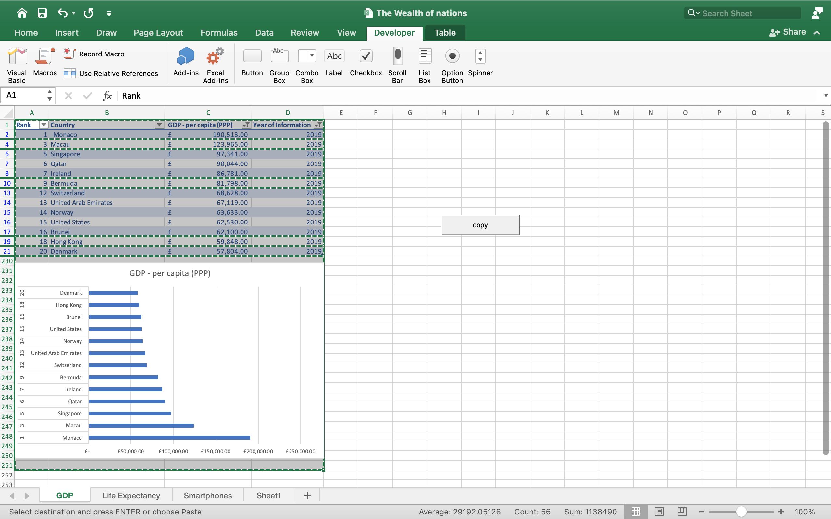

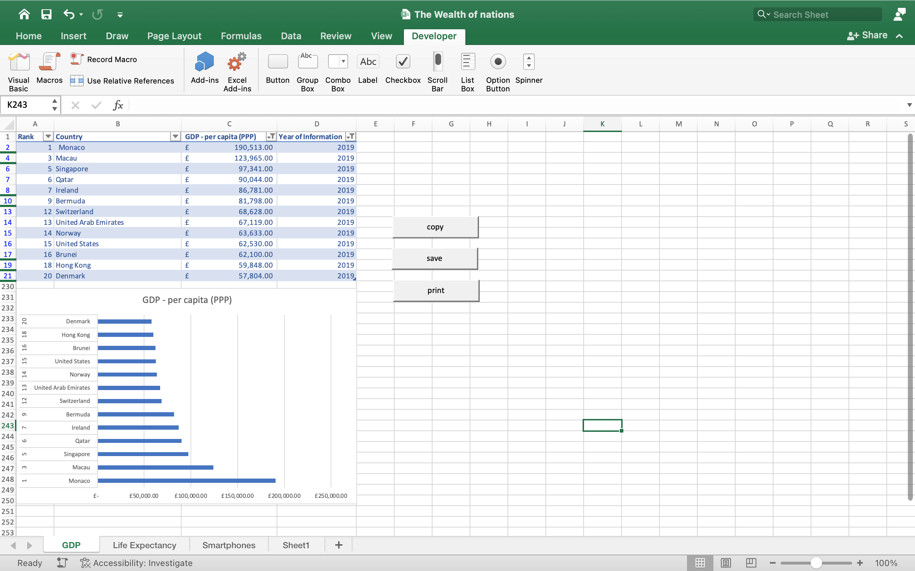

**GDP**

|  |  |  |  |
| --- | --- | --- | --- |
| **Rank** | **Country** | **GDP - per capita (PPP)** | **Year of Information** |
| 1 | Monaco | £ 190,513.00 | 2019 |
| 3 | Macau | £ 123,965.00 | 2019 |
| 5 | Singapore | £ 97,341.00 | 2019 |
| 6 | Qatar | £ 90,044.00 | 2019 |
| 7 | Ireland | £ 86,781.00 | 2019 |
| 9 | Bermuda | £ 81,798.00 | 2019 |
| 12 | Switzerland | £ 68,628.00 | 2019 |
| 13 | United Arab Emirates | £ 67,119.00 | 2019 |
| 14 | Norway | £ 63,633.00 | 2019 |
| 15 | United States | £ 62,530.00 | 2019 |
| 16 | Brunei | £ 62,100.00 | 2019 |
| 18 | Hong Kong | £ 59,848.00 | 2019 |
| 20 | Denmark | £ 57,804.00 | 2019 |
| |  | | --- | |  | |  |  |  |
|  |  |  |  |
|  |  |  |  |
|  |  |  |  |
|  |  |  |  |
|  |  |  |  |
|  |  |  |  |
|  |  |  |  |
|  |  |  |  |
|  |  |  |  |
|  |  |  |  |
|  |  |  |  |
|  |  |  |  |
|  |  |  |  |
|  |  |  |  |
|  |  |  |  |
|  |  |  |  |
|  |  |  |  |
|  |  |  |  |
|  |  |  |  |
|  |  |  |  |
|  |  |  |  |
|  |  |  |  |

## **A REFLECTION**

THIS ASSIGNMENT HAS GIVEN ME MORE INSIGHT AND UNDERSTANDING. IT WAS INTERESTING GOING THROUGH EVERYTHING I HAVE LEARNT FROM DAY 1. I HAVE LEARNT TO PAY ATTENTION TO DETAILS AND INSTRUCTIONS. ONE MISSED STEP CAN CAUSE SEVERE CONFUSION ESPECIALLY WHEN USING TOOLS LIKE EXCEL AND TABLEAU.